

Marketing Research & Analysis

(Dr. BRYSON)

**GROUP ASSIGNMENT #2**

**ARISTIZABAL MUNOZ**, Juan Pablo

**SIRAME**, Prajakta digambar

**LIEANDER**, Timothy Jevon

**YANG**, Yaojie

**BERA**, Pooja

|  |  |
| --- | --- |
| Bryson et al. (2013) proposed four main potential antecedents for brand hate: the brand’s country of origin, customer dissatisfaction, negative stereotypes of its consumers and corporate social performance. | Bryson, D., Atwal, G. and Hultén, P. (2013), Towards the conceptualisation of the antecedents of extreme negative affect towards luxury brands, *Qualitative Market Research*, Vol. 16 No. 4, pp. 393-405. <https://doi.org/10.1108/QMR-06-2013-0043> |
| Academic literature has also presented three main motives or antecedents for brand hate as the avoidance of experiential brand, identity and moral, and six outcomes in brand exit, brand rejection, and four revenge behaviors; either indirect, negative word of mouth and online complaining; or direct, vindictive complaining and marketplace aggression (Delzen, 2014). | Delzen, M. van (2014). *Identifying the motives and behaviours of brand hate*. Retrieved April 17, 2021, from http://essay.utwente.nl/64731/ |
| **Brand and Emotions**  There is no doubt that hatred is a multifaceted term. Although some scholars consider hatred to be a basic emotion, most scholars consider it to be a main and often secondary emotion. While both brand hate and brand avoidance have been related to the purpose of refusing or opposing a brand, only brand hate has been linked to habits such as expressing unfavourable emotions, boycotting, or sabotaging company property.  Consumer buying behaviour is heavily influenced by impulses, according to researchers. Consumers base their purchasing choices on their thoughts and emotions regarding specific products and often buy brands for what they represent (Gelbrich, 2009). Consumer-brand emotion (CBE) is described as "a state of emotional attachment marked by a deep positive affection for the brand and a tendency for the brand to control the consumers' cognition."  They discern between positive and negative influence, for starters. Rage, fear, depression, and shamefulness are the four main feelings associated with negative affect. Positive affect is often comprised of two essential emotions: contentment and pleasure. Rage, tenseness, sorrow, humiliation, satisfaction, and optimism are among the 42 specific emotions in customer behaviour that can be categorized into six core emotions. | Gelbrich, K. (2009). Beyond just being dissatisfied: How angry and helpless customers react to failures when using self-service technologies. Schmalenbach Business Review, 61(2), 40–59. |
| **Motivation for brand hate**  Many researchers in the fields of psychology and marketing have wondered what drives people to purchase such goods. What requirements do they have to meet? What are their objectives? What are the beliefs and identities that lie behind it all? As a result, several experiments on the subject of inspiration have been published. (Blackwell, Miniard, & Engel, 2006; Mitchell, 1997; Parks & Guay, 2009 ). However, there has been little research on whether people want not to buy a certain product, service, or brand.  *Experiential avoidance:* Negative interactions with a product can lead to a dislike of the brand. Bad brand experiences lead to disappointment, which then leads to brand avoidance. In other words, when customer needs are not met, brand avoidance occurs. Product loss, low service, low performance, and an unfavourable retail experience can all lead to brand avoidance.  *Identity avoidance*: Identity avoidance occurs as consumers reject products that do not complement their identity or when a brand is closely associated with such classes. When a community is affiliated with a single brand, people do not want to be a part of it. Furthermore, some customers want to be seen as exclusive, so they steer clear of mainstream brands.  *Moral avoidance*: The country-of-origin results are a special form of moral avoidance. The conditions under which goods are made, the atmosphere in which the company manufactures, and how the company handles its workers are all covered by country-of-origin impacts. The most critical aspects of spiritual avoidance are resistance to dominating influences, a social emphasis that extends beyond the person, and a social focus that extends beyond the individual, and a broader social emphasis than just the citizen. | • Gelbrich, K. (2009). Beyond just being dissatisfied: How angry and helpless customers react to failures when using self-service technologies. Schmalenbach Business Review, 61(2), 40–59.  • Blackwell, R. D., Miniard, P. W., & Engel, J. F. (2006). Consumer behavior (10th ed.). Mason: Thomson South-Western |
| **Brand hate behaviour:**  Avoidance of approach Motivation is often linked to an individual's emotional state and promotes a variety of behavioural outcomes. Consumer revenge can be classified into four categories: cost/loss, consumption prevention, boycott and shopping slowdown, and escape, speech, and betrayal. Furthermore, Grégoire et al. (2009) suggest that customers' hatred will manifest itself in two ways: avoidance and retaliation. They discovered that revenge behaviour reduces over time because it requires more energy from the user than retaliation behaviour.  *Exit and rejection:* It notes that disgruntled customers may either appeal to the company or end their partnership with the company. Exit in this sense refers to the termination of a contract by ceasing to purchase the company's goods. Furthermore, brand rejection is more powerful than brand exit, and it is described as "incidents in which customers chose to reject a brand." These habits can also be applied to brand hatred's result behaviors. As a result, the following theories emerge: | Gregoire, Y., Tripp, T. T., & Legoux, R. (2009). When customer love turns into lasting hate: The effects of relationship strength and time on customer revenge and avoidance. Journal of Marketing, 73(6), 18-32. |
| Hegner et al. (2017) proposed a model for brand hate with six main constructs, three determinants: negative past experience, ideological incompatibility and symbolic incongruity; and three outcomes: negative word of mouth, brand avoidance and brand retaliation.  Pinto and Brandão (2021) also worked using this model and further explored it by analysing brand hate as a mediator in the relationship between the determinants and consequences. | Hegner, S.M., Fetscherin, M. and van Delzen, M. (2017), Determinants and outcomes of brand hate, *Journal of Product & Brand Management*, Vol. 26 No. 1, pp. 13-25. <https://doi.org/10.1108/JPBM-01-2016-1070>  Pinto, O. and Brandão, A. (2021), Antecedents and consequences of brand hate: empirical evidence from the telecommunication industry, *European Journal of Management and Business Economics*, Vol. 30 No. 1, pp. 18-35. https://doi.org/10.1108/EJMBE-04-2020-0084 |
| Zarantonello et al. (2016) proposed a model where the antecedents are expressed in a behavioural manner in anger, contempt & disgust, fear, disappointment, shame, and dehumanization, with four main outcomes in complaining, negative word of mouth, protest, and patronage reduction/cessation. | Zarantonello, L., Romani, S., Grappi, S. and Bagozzi, R.P. (2016), Brand hate, *Journal of Product & Brand Management*, Vol. 25 No. 1, pp. 11-25. https://doi.org/10.1108/JPBM-01-2015-0799 |
| According to Fournier (1998), brands give consumers meaning to their lives. Marketers and companies are often interested in the purchasing behaviour of consumers, since consumers purchase products for the positive feeling that it releases (Lee et al., 2009). Consumers seek to identify themselves and express themselves through brands (Fournier, 1998). There is a continuous increase in the interest of researching positive Consumer Brand Relationships, however, in the marketing literature, brand hate, and negative feelings towards brands, have been highly neglected (Batra et al., 2012). | Fournier, S. (1998). Consumers and their brands: Developing relationship theory in consumer research. Journal of Consumer Research 24: 343-353 |

**HYPOTHESIS:**

H1: Brand hatred has a positive impact on the brand's departure.

H2: Brand hatred has a positive impact on brand rejection.

H3 : Attitude towards Advertisement is an antecedent of Brand Hate

H4: Moral Violation is an antecedent of Brand Hate

H5 : Negative Stereotypes is an antecedent of Brand Hate

H6 : Product Quality is an antecedent of Brand Hate

H7 : Corporate Social Responsibility is an antecedent of Brand Hate

H8 : Subjective Norm is an antecedent of Brand Hate

H9 : Boycotting is an outcome of Brand Hate

H10 : Brand Avoidance is an outcome of Brand Hate

H11: Negative Word-of-Mouth is an outcome of Brand Hate

H12 : Social Feedbacks is an outcome of Brand Hate

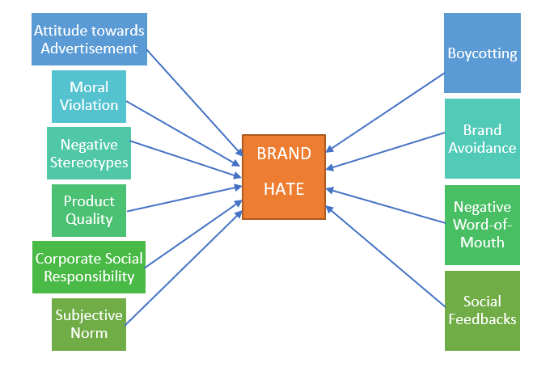BRAND HATE MODEL